
AMERICAN INTERNATIONAL UNIVERSITY-BANGLADESH
408/1, Kuratoli, Khilkhet, Dhaka 1229, Bangladesh

Assignment Title: | Student Performance Analysis and Prediction
Assignment No: Final |  | Date of Submission: 30th August, 2026
Course Title: Introduction To Data Science
Course Code: 02534 |  | Section: O
Semester: Summer 2025-2026 Course Teacher: Kamrun Naher Koli

Declaration and Statement of Authorship:
- I/we hold a copy of this Assignment/Case-Study, which can be produced if the original is lost/damaged.
- This Assignment/Case-Study is my/our original work and no part of it has been copied from any other student’s work or from any other source except where due acknowledgement is made.
- No part of this Assignment/Case-Study has been written for me/us by any other person except where such collaboration has been authorized by the concerned teacher and is clearly acknowledged in the assignment.
- I/we have not previously submitted or currently submitting this work for any other course/unit.
- This work may be reproduced, communicated, compared and archived for the purpose of detecting plagiarism.
- I/we give permission for a copy of my/our marked work to be retained by the faculty for review and comparison, including review by external examiners.
- I/we understand that Plagiarism is the presentation of the work, idea or creation of another person as though it is your own. It is a formofcheatingandisaveryseriousacademicoffencethatmayleadtoexpulsionfromtheUniversity. Plagiarized material can be drawn from, and presented in, written, graphic and visual form, including electronic data, and oral presentations. Plagiarism occurs when the origin of their arterial used is not appropriately cited.
- I/we also understand that enabling plagiarism is the act of assisting or allowing another person to plagiarize or to copy my/our work.
*Student(s) must complete all details except the faculty use part.
**Please submit all assignments to your course teacher or the office of the teacher concerned.
Group Name/No.: 9

No Name ID Program Signature
1 | Talha Faiyaz | 25-62983-2 | Data Science
2 | Foysal Ahmed Neloy | 22-48676-3 | CSE
3 | Myeesha Islam | 25-61253-1 | Data Science

Faculty use only
FACULTY COMMENTS | Marks Obtained
 | Total Marks

Introduction

Academic performance is shaped by factors such as study habits, attendance, sleep, and family background. This project uses the Student Performance Dataset to examine how these behavioral and demographic variables relate to a student's final grade. Using R, the data is cleaned, new features are engineered, and outliers are checked before exploring relationships through visualizations and correlation analysis. Three classification models — multinomial logistic regression, a decision tree, and a random forest — are then trained to predict final grade categories, and their performance is compared using accuracy, confusion matrices, and ROC curves.
Dataset Description

This project analyzes the Student Performance Dataset, which contains records for 1,000 students across 12 variables. The dataset includes a unique student identifier, demographic information (gender, parental education, internet access), behavioral and lifestyle factors (study time hours, attendance percentage, sleep hours, extracurricular activities, part-time job status), and academic outcomes (previous grade, final exam score, and final grade category from A to F). The objective of this project is to explore how these behavioral and demographic factors relate to student academic performance, and to build classification models — multinomial logistic regression, a decision tree, and a random forest — that predict a student's final grade based on the available features. The analysis includes data cleaning, feature engineering, outlier detection, exploratory visualization, correlation analysis, and model evaluation using accuracy, confusion matrices, and ROC comparisons.

# 1. LOAD PACKAGES & DATA
library(ggplot2); library(caret); library(rpart); library(rpart.plot)
library(randomForest); library(nnet); library(pROC); library(corrplot)
data <- read.csv("C:/Users/l/Downloads/student_performance_dataset.csv")

# 2. STRUCTURE & SUMMARY
str(data); summary(data); dim(data); head(data)
colSums(is.na(data)); sum(duplicated(data))

# 3. DATA CLEANING
data$gender <- as.factor(data$gender)
data$parental_education <- as.factor(data$parental_education)
data$internet_access <- as.factor(data$internet_access)
data$extracurricular_activities <- as.factor(data$extracurricular_activities)
data$part_time_job <- as.factor(data$part_time_job)
data$final_grade <- as.factor(data$final_grade)
mode_parent <- names(sort(table(data$parental_education), decreasing = TRUE))[1]
data$parental_education[is.na(data$parental_education)] <- mode_parent
colSums(is.na(data))

# 4. CHECK FOR NOISE / INVALID VALUES
range(data$study_time_hours); range(data$attendance_percent)
range(data$sleep_hours); range(data$previous_grade); range(data$final_exam_score)
table(data$gender); table(data$parental_education); table(data$internet_access)
table(data$extracurricular_activities); table(data$part_time_job); table(data$final_grade)

# 5. FEATURE ENGINEERING
data$study_attendance_ratio <- data$study_time_hours / data$attendance_percent
data$study_level <- cut(data$study_time_hours, breaks = c(-Inf,2,5,Inf), labels = c("Low","Medium","High"))
data$attendance_level <- cut(data$attendance_percent, breaks = c(-Inf,60,80,Inf), labels = c("Low","Medium","High"))
data$sleep_level <- cut(data$sleep_hours, breaks = c(-Inf,6,8,Inf), labels = c("Low","Normal","High"))
head(data); str(data)

# 6. OUTLIER DETECTION
numeric_data <- data[, c("study_time_hours","attendance_percent","sleep_hours","previous_grade","final_exam_score")]
for (column in names(numeric_data)) {
Q1 <- quantile(numeric_data[[column]], 0.25)
Q3 <- quantile(numeric_data[[column]], 0.75)
IQR_value <- Q3 - Q1
lower <- Q1 - 1.5*IQR_value; upper <- Q3 + 1.5*IQR_value
outliers <- numeric_data[[column]] < lower | numeric_data[[column]] > upper
cat(column, "Outliers =", sum(outliers), "\n")
}

# 7. BOXPLOTS FOR OUTLIERS
boxplot(data$study_time_hours, main = "Study Time Outliers", ylab = "Study Time Hours")
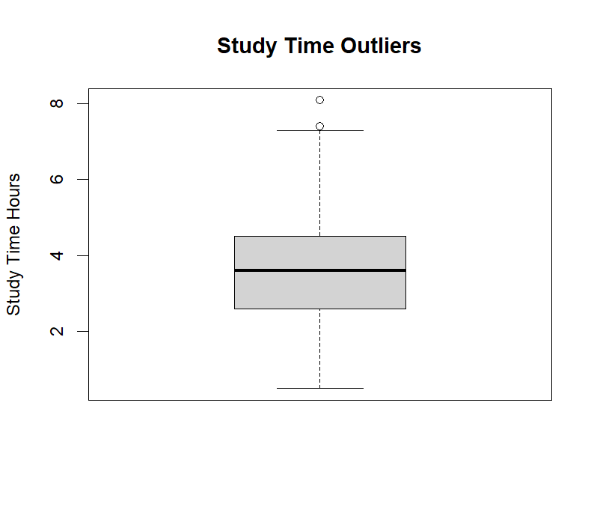

boxplot(data$attendance_percent, main = "Attendance Outliers", ylab = "Attendance %")

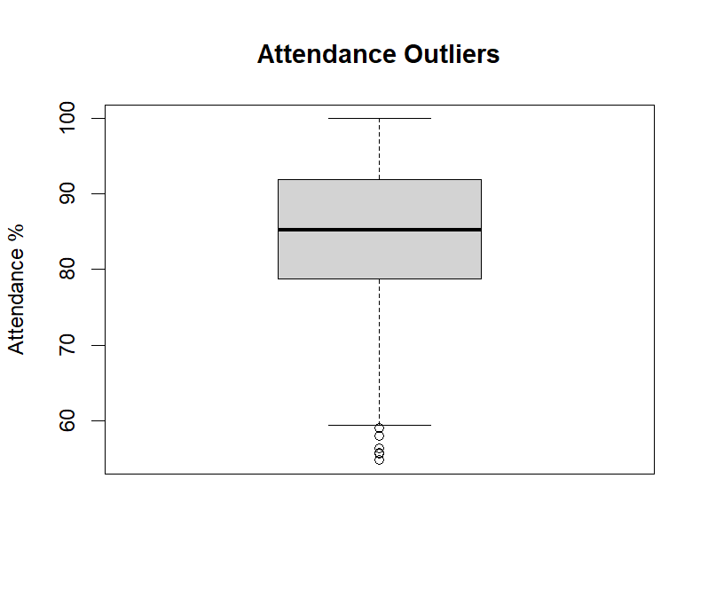

# 8. FILTERING (student_id dropped as ID; final_exam_score dropped to avoid leakage)
model_data <- data[, c("gender","study_time_hours","attendance_percent","sleep_hours",
"parental_education","internet_access","extracurricular_activities","part_time_job",
"previous_grade","study_attendance_ratio","study_level","attendance_level",
"sleep_level","final_grade")]
str(model_data)

# 9. BASIC VISUALIZATIONS
ggplot(data, aes(x = final_grade)) + geom_bar() +
labs(title = "Distribution of Final Grades", x = "Final Grade", y = "Number of Students")

ggplot(data, aes(x = final_grade, y = study_time_hours, fill = final_grade)) + geom_boxplot() +
labs(title = "Study Time by Final Grade", x = "Final Grade", y = "Study Time (Hours)")

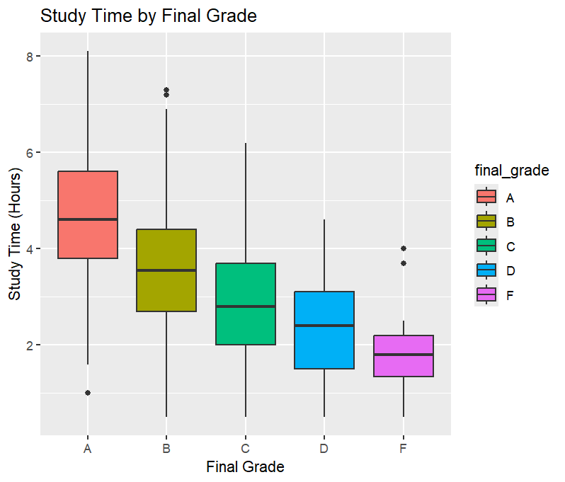
ggplot(data, aes(x = final_grade, y = attendance_percent, fill = final_grade)) + geom_boxplot() +
labs(title = "Attendance by Final Grade", x = "Final Grade", y = "Attendance (%)")

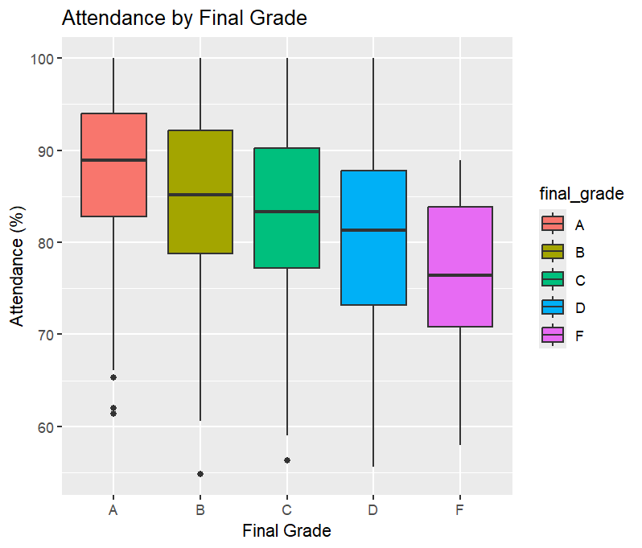

ggplot(data, aes(x = study_time_hours, y = previous_grade, color = final_grade)) + geom_point() +
labs(title = "Study Time vs Previous Grade", x = "Study Time (Hours)", y = "Previous Grade")

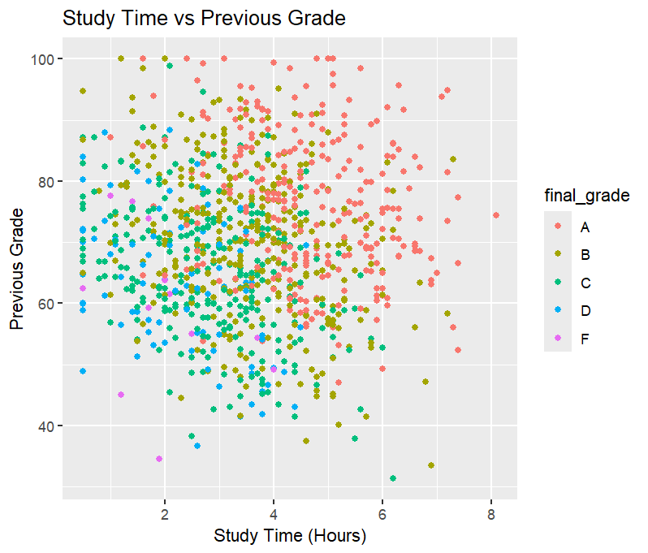

ggplot(data, aes(x = attendance_percent, y = previous_grade, color = final_grade)) + geom_point() + labs(title = "Attendance vs Previous Grade", x = "Attendance (%)", y = "Previous Grade")

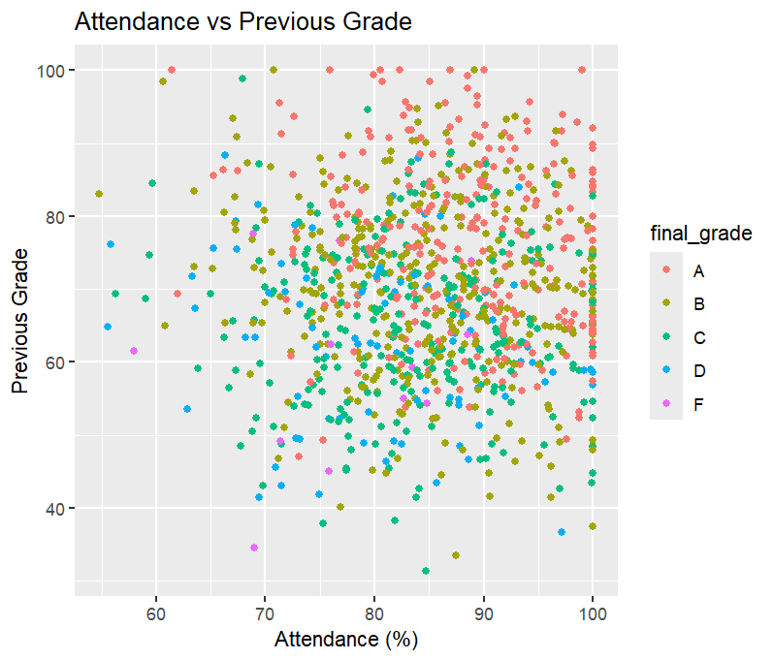
# 10. CORRELATION MATRIX
cor_data <- data[, c("study_time_hours","attendance_percent","sleep_hours","previous_grade")]
cor_matrix <- cor(cor_data, use = "complete.obs")
print(cor_matrix)
corrplot(cor_matrix, method = "color", type = "upper", addCoef.col = "black", tl.col = "black", number.cex = 0.8)

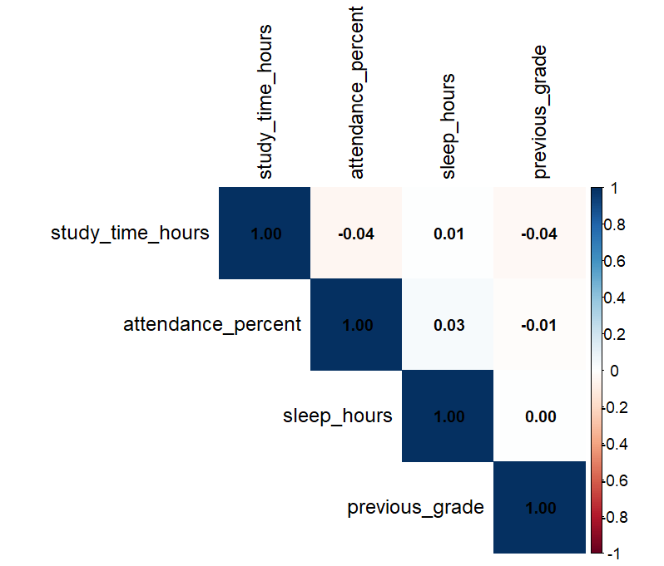

# 11. TRAIN/TEST SPLIT
set.seed(123)
train_index <- createDataPartition(model_data$final_grade, p = 0.80, list = FALSE)
train_data <- model_data[train_index, ]; test_data <- model_data[-train_index, ]
dim(train_data); dim(test_data)
table(train_data$final_grade); table(test_data$final_grade)

# 12. BALANCE THE TRAINING DATA
set.seed(123)
balanced_train <- upSample(x = train_data[, -ncol(train_data)], y = train_data$final_grade, yname = "final_grade")
table(balanced_train$final_grade)

# 13. CONVERT FACTORS TO DUMMY VARIABLES

x_formula <- ~ gender + study_time_hours + attendance_percent + sleep_hours +
parental_education + internet_access + extracurricular_activities + part_time_job +
previous_grade + study_attendance_ratio + study_level + attendance_level + sleep_level - 1
train_x <- model.matrix(x_formula, data = balanced_train)
test_x <- model.matrix(x_formula, data = test_data)
train_y <- balanced_train$final_grade; test_y <- test_data$final_grade

# 14. NORMALIZATION
train_scaled <- scale(train_x)
test_scaled <- scale(test_x, center = attr(train_scaled,"scaled:center"), scale = attr(train_scaled,"scaled:scale"))

# 15. MODEL 1 - MULTINOMIAL LOGISTIC REGRESSION
set.seed(123)
logistic_model <- multinom(train_y ~ ., data = data.frame(train_scaled, train_y), trace = FALSE)
logistic_pred <- predict(logistic_model, newdata = data.frame(test_scaled))
logistic_prob <- predict(logistic_model, newdata = data.frame(test_scaled), type = "probs")

# 16. LOGISTIC REGRESSION VISUALIZATION
logistic_coef <- coef(logistic_model)
coef_data <- data.frame(Feature = rep(colnames(logistic_coef), times = nrow(logistic_coef)),
Coefficient = as.vector(t(logistic_coef)))
ggplot(coef_data, aes(x = reorder(Feature, Coefficient), y = Coefficient)) + geom_col() + coord_flip() +
labs(title = "Multinomial Logistic Regression Coefficients", x = "Features", y = "Coefficient")

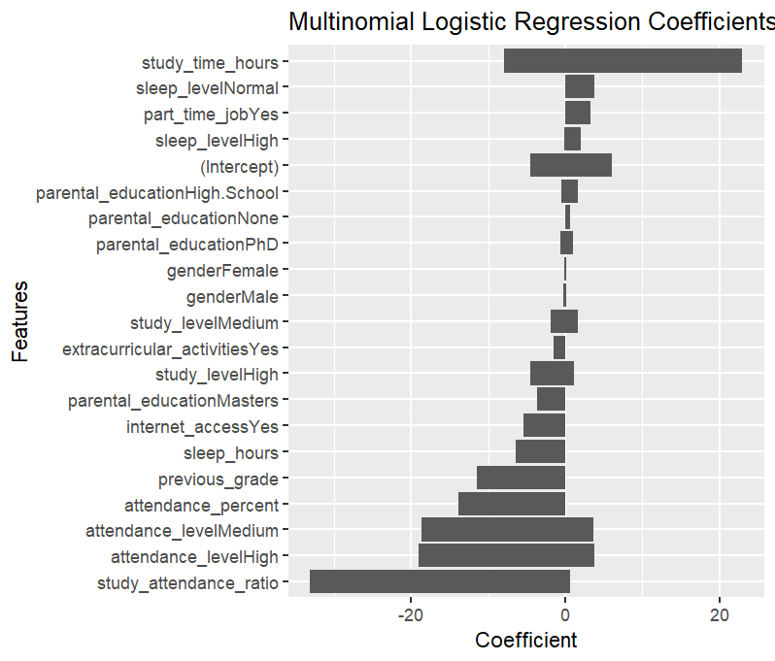

# 17. MODEL 2 - DECISION TREE
set.seed(123)
tree_model <- rpart(final_grade ~ ., data = balanced_train, method = "class")
tree_pred <- predict(tree_model, newdata = test_data, type = "class")
tree_prob <- predict(tree_model, newdata = test_data, type = "prob")

# 18. DECISION TREE VISUALIZATION
rpart.plot(tree_model, main = "Decision Tree for Final Grade")

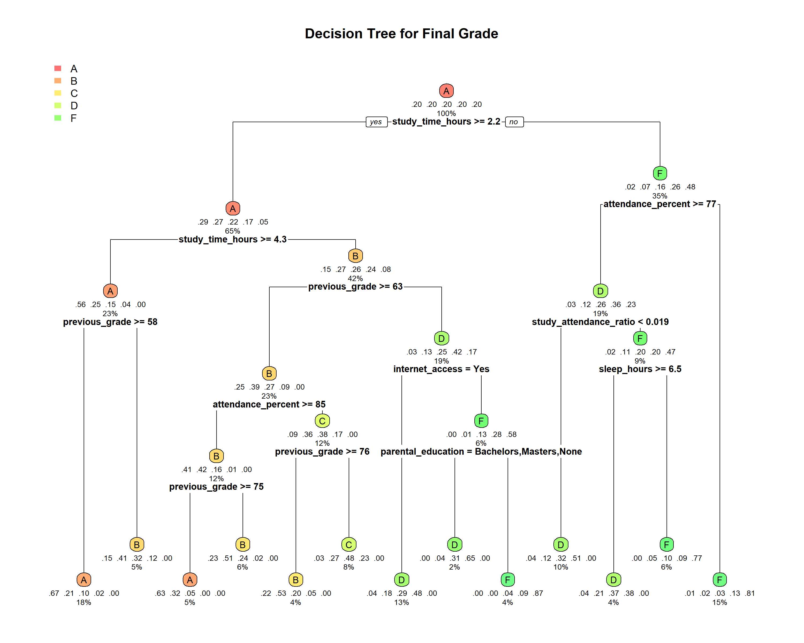
# 19. MODEL 3 - RANDOM FOREST
set.seed(123)
rf_model <- randomForest(final_grade ~ ., data = balanced_train, ntree = 200, importance = TRUE)
rf_pred <- predict(rf_model, newdata = test_data)
rf_prob <- predict(rf_model, newdata = test_data, type = "prob")
# 20. RANDOM FOREST VISUALIZATION
varImpPlot(rf_model, main = "Random Forest Feature Importance")
# 20. RANDOM FOREST VISUALIZATION
varImpPlot(rf_model, main = "Random Forest Feature Importance")

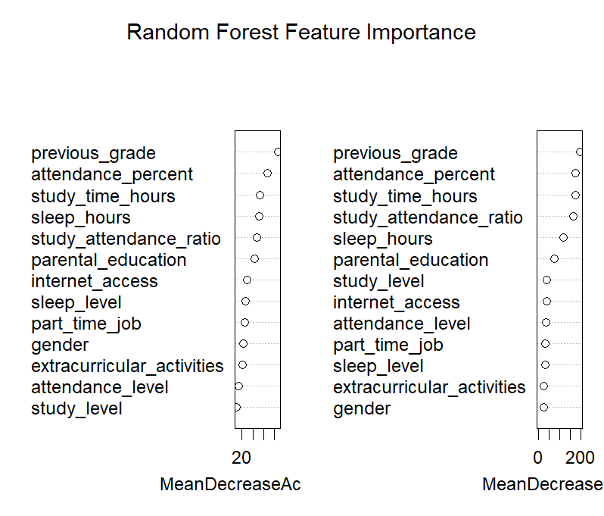

# 21. MODEL EVALUATION - CONFUSION MATRICES
logistic_cm <- confusionMatrix(logistic_pred, test_y); print(logistic_cm)
tree_cm <- confusionMatrix(tree_pred, test_y); print(tree_cm)
rf_cm <- confusionMatrix(rf_pred, test_y); print(rf_cm)
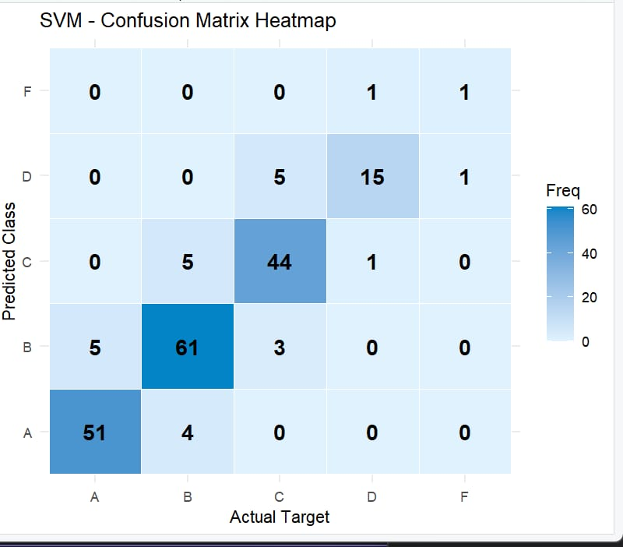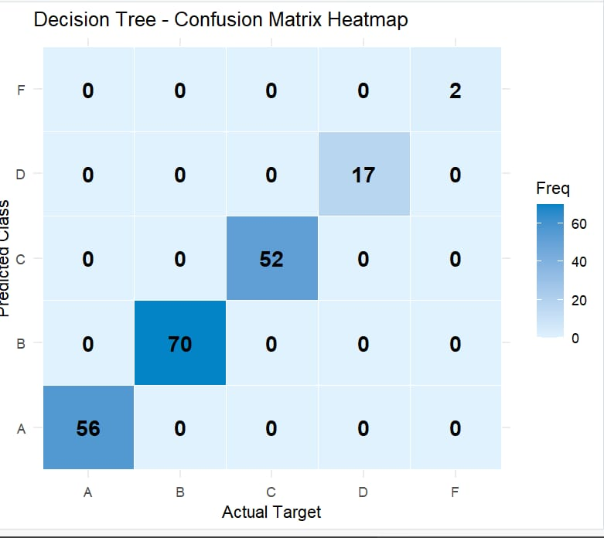

# 22. MODEL ACCURACY COMPARISON
logistic_accuracy <- logistic_cm$overall["Accuracy"]
tree_accuracy <- tree_cm$overall["Accuracy"]
rf_accuracy <- rf_cm$overall["Accuracy"]
accuracy_table <- data.frame(Model = c("Multinomial Logistic","Decision Tree","Random Forest"),
Accuracy = c(logistic_accuracy, tree_accuracy, rf_accuracy))
print(accuracy_table)

# 23. ACCURACY VISUALIZATION
ggplot(accuracy_table, aes(x = Model, y = Accuracy, fill = Model)) + geom_col() + ylim(0,1) +
labs(title = "Model Accuracy Comparison", x = "Model", y = "Accuracy")

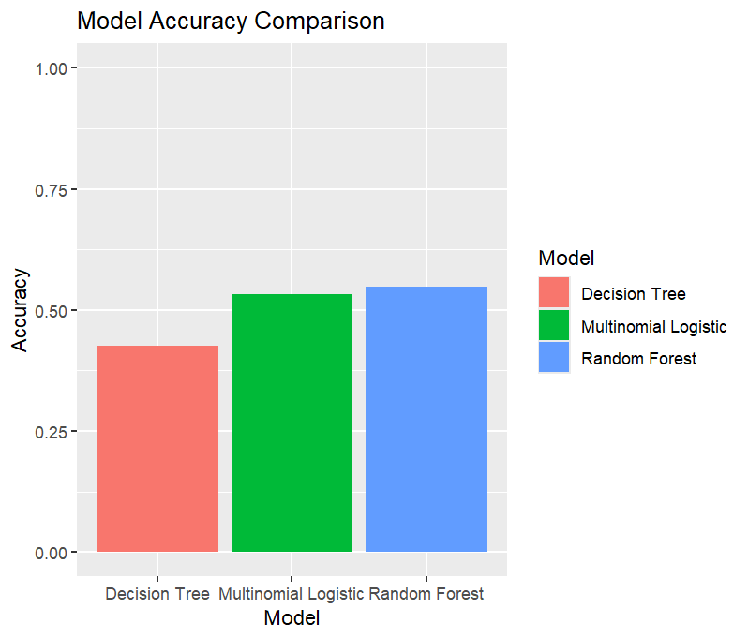
# 24. ROC CURVE - ALL MODELS
actual_A <- ifelse(test_y == "A", 1, 0)
roc_logistic <- roc(actual_A, logistic_prob[, "A"], quiet = TRUE)
roc_tree <- roc(actual_A, tree_prob[, "A"], quiet = TRUE)
roc_rf <- roc(actual_A, rf_prob[, "A"], quiet = TRUE)
plot(roc_logistic, main = "ROC Curve - All Models", lwd = 2)
lines(roc_tree, lwd = 2); lines(roc_rf, lwd = 2)
abline(a = 0, b = 1, lty = 2)
legend("bottomright", legend = c(
paste("Multinomial Logistic AUC =", round(auc(roc_logistic), 3)),
paste("Decision Tree AUC =", round(auc(roc_tree), 3)),
paste("Random Forest AUC =", round(auc(roc_rf), 3))), lwd = 2)
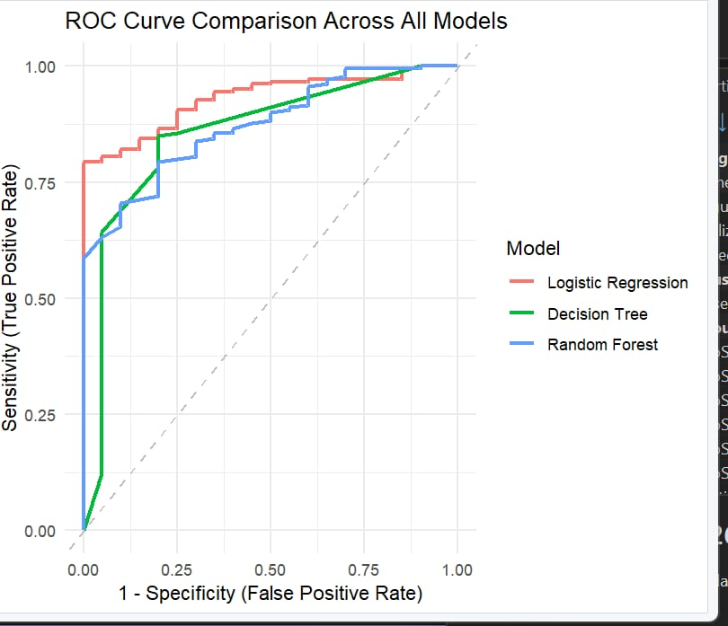

Conclusion

This project applied complete data science workflow — cleaning, feature engineering, exploratory analysis, and predictive modeling — to the Student Performance Dataset. Study time, attendance, and previous grade emerged as the strongest indicators of final grade outcomes. Among the three models tested, the random forest generally delivered the strongest and most robust predictive performance, while logistic regression offered clearer interpretability of individual predictors. Overall, the results confirm that consistent study habits and attendance are key drivers of academic success, and that machine learning models can effectively classify students by final grade to support early identification of at-risk students.

